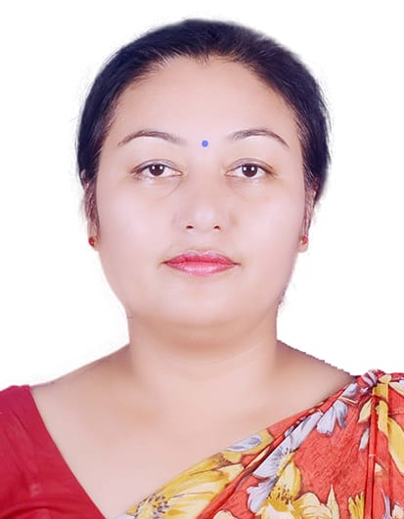
Prabina Shrestha
Lecturer
Balkumari Campus
Narayangarh, Chitwan
9845050478, 9855093125
prabinashrestha031@gmail.com
Personal Profile:
Date of Birth: 2031/06/28
Gender: Female
Nationality: Nepali
Marital Status: Married
Religion: Hindu
Permanent Address: Mainroad, Narayangarh
Bharatpur Metropolitan-1
Chitwan, Bagmati Province
Education:
2024-2026 Master of Philosophy(M.Phil.) in Management 3.89 CGPA
Tribhuvan University, Kirtipur
1998-1999 Master’s Degree in Business Administration 59.68%
Tribhuvan University, Kirtipur
1995-1997 Bachelor’s Degree in Business Administration 46.50%
Tribhuvan University, Kirtipur
1993-1994 Proficiency Certificate Level in Pharmacy 71.60%
IOM, Maharagunj, Tribhuvan University
1990 School Leaving Certificate 74.14%
Balkumari Secondary School, SLC Board

Work Experience:
1995-1996 worked in Simca Laboratories Pvt. Ltd. as Pharmacy Assistant
1996-1999 taught as an instructor to CMA & ANM in Balkumari Nursing College
- Pharmacy and Anatomy
- Project works on Community Survey
- Presentation on Community Survey
2000-2024 Asst. Lecturer in Management (Part-Time)
Lecturer in Management (Permanent)
Program Coordinator (Management, Day Shift)
Balkumari College
2024- till date Vice Principal, Balkumari College
2023-Present Teaching different subjects of management stream in Balkumari Campus

Research and Article Publication:
- Research: What and How? Published in Journal of Balkumari College, Vol. 1,2066
- Public Participation in Infrastructure Development of Community Colleges in Nepal with special reference to infrastructure development of Balkumari College published in NIIFC, 2010
- Corporate Culture and Organisational Performance: A Review of Literature published in Nepalese Journal of Management Research, Peer Reviewed Journal, Vol.4 and Nepal Journals online, www.nepjol.info, Jan. 2024
- Balkumari College: Advancing Toward Excellence in Quality Education, Balkumri Souvenir, 2082
- Aligning Corporate Values with Rotary Club Performance, Pinnacle Rotary Souvenir 2025/26
- Rotarian as a Social Entrepreneur: Transforming Communities Through Service and Innovation, Pinnacle Rotary Souvenir 2026/27

Participation:
- Nepal International Infrastructure Finance Conference (NIIFC, 2010).
- Training and Workshop in Research Methodology, 2009.
- 3days Faculty Development Program 2023 organized by Purbanchal University.
- Workshop entitled Developing Research Career and publication, 2023
- Workshop on Application of Excel in Analyzing and Visualizing Data (AEAVD-2018)
- Training Preparation on Health Logistics 2005, organized by Nepal Family Health Program and CTEVT, 2005
- Two days workshop on Designing Seminar Paper, Article Writing, Publication and Pedagogical Approaches, 2023
- 7days Teacher Training/Orientation Program organized by Curriculum and Training Division, HSE Board, 2068
- Reducing HIV Stigma in Health Care Settings conducted by Nepal Medical Association (NMA), 2063
- Workshop on Research Methodology and Thesis/Report Writing, 2073
- National conference on Nepalese Higher Education: Education and Learning Through Social Innovation, 2023
- Digital Pedagogy Training organized by Training Unit, Balkumari College, supported by UGC, Nepal, 2082
- Five Day Workshop on Data Analysis Using MS-Excel, 10-15 May, 2025 organized by RMC, Balkumari College supported by UGC, Nepal
- Teachers’ Professional Development Training Program (TPDTP) 2nd Cohort, 14th -20th Chaitra 2082, UGC, Nepal
- A Three-Day Workshop on Article Writing, 15th-17th Jestha, 2083, organized by RMC, Balkumari College, supported by UGC, Nepal
- Training on Good Governance for Community Campuses, May 22-24, 2026, UGC,Nepal

Research Paper Presentation:
- Public Participation in Infrastructure Development of Community Colleges in Nepal with special reference to infrastructure development of Balkumari College Nepal International Infrastructure Finance Conference (NIIFC, 2010).
- Socio-Cultural Influence on Women’s Entrepreneurship in Chitwan District, Nepal at International Conference-2024 on Inclusive and sustainable Development through Transformation, Innovation and Digitalization.
- Impact of Micro-Economic Variable On Corporate Capital Structure in Listed Manufacturing Companies in Neapl, at National Conference on Reforming Higher Education in Time of Crisis: Strategies for Retention, Quality and Societal Impact organized by Madhyabindu Multiple Campus, 2025

Social Involvements:
- Executive Member, Narayani Kala Mandir
- Past President, Lions Club of Balkumari College
- Executive Member, Spouse Club of Rotary Club of Narayangarh
- Member, Chitwan Chamber of Commerce and Industry
- Secretary, Narayangarh Newa Puch
- Secretary, Abhiyan Cooperative Society

